Book

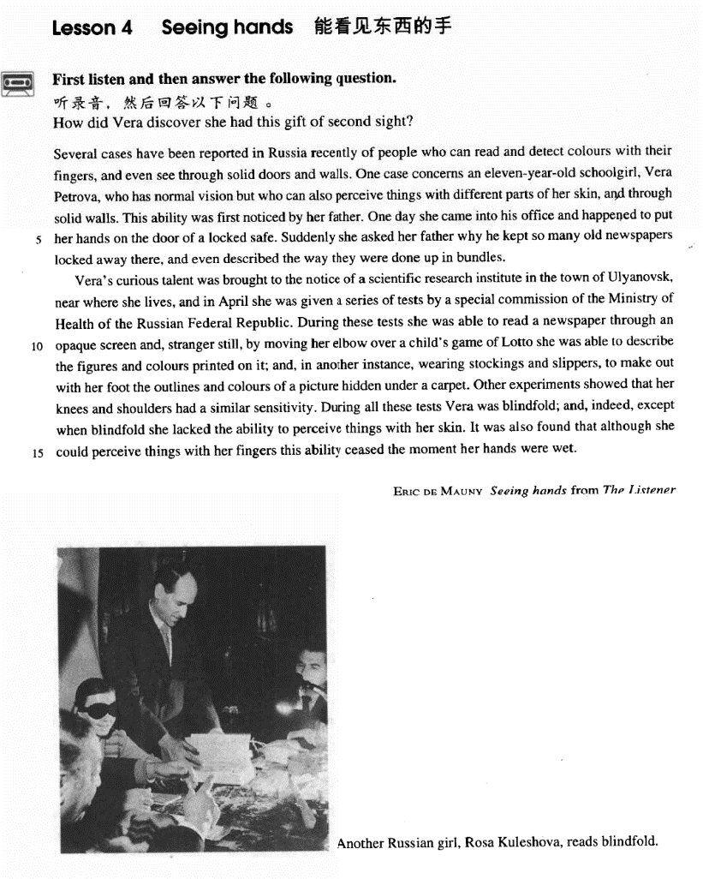

课文

Several cases have been reported in Russia recently of people who can read and detect colours with their fingers, and even see through solid doors and walls.

俄罗斯最近报导了几个事例，有人能用手指看书识字和辨认颜色，甚至能透过厚实的门和墙看到东西。

One case concerns an eleven-year-old schoolgirl Vera Petrova, who has normal vision but who can also perceive things with different parts of her skin, and through solid walls.

其中有一例谈到有一个名叫维拉.彼托洛娃的11岁学生，她的视力与常人一样，但她还能用皮肤的不同部位辨认东西，甚至看穿坚实的墙壁。

This ability was first noticed by her father.

是她父亲首先发现她这一功能的。

One day she came into his office and happened to put her hands on the door of a locked safe.

一天，维拉走进父亲的办公室，偶然把手放在一个锁着的保险柜的门上，

Suddenly she asked her father why he kept so many old newspapers locked away there, and even described the way they were done up in bundles.

她突然问父亲为什么把这么多的旧报纸锁在柜子里，还说了报纸捆扎的情况。

Vera's curious talent was brought to the notice of a scientific research institute in the town of Ulyanovsk, near where she lives, and in April she was given a series of tests by a special commission of the Ministry of Health of the Russian Federal Republic.

维拉的特异功能引起了她家附近乌里扬诺夫斯克城一个科研单位的注意，4月里俄罗斯卫生部一个特别委员会对她进行了一系列的测试。

During these tests she was able to read a newspaper through an opaque screen and, stranger still, by moving her elbow over a child's game of Lotto she was able to describe the figures and colours printed on it; and, in another instance, wearing stockings and slippers, to make out with her foot the outlines and colours of a picture hidden under a carpet.

在这些测试中，她能隔着不透明的屏幕读报纸。更为奇怪的是，她把肘部在儿童玩的“罗托”纸牌上移动一下，便能说出印在纸牌上的数字和颜色；还有一次，她穿着长筒袜子和拖鞋，能用脚步识别出藏在地毯下面的一幅画的轮廓和颜色。

Other experiments showed that her knees and shoulders had a similar sensitivity.

其他实验表明，她的膝盖和双肩有类似的感觉能力。

During all these tests Vera was blindfold; and indeed, except when blindfold she lacked the ability to perceive things with her skin.

在所有这些实验中，维拉的双眼都是蒙着的。如果不蒙上双眼她的皮肤就不再具有识别物体的能力。

It was also found that although she could perceive things with her fingers this ability ceased the moment her hands were wet.

这是千真万确的。同时还发现，尽管她能用手指识别东西，但她的手一旦弄湿，这种功能便会立即消失。

词汇讲解

### solid

* **solid** ['sɒlɪd] adj. 结实的；实心的；立体的

**solid** adj. **含义1：** firm; hard; strong solid doors and walls 结实的

* The villa has **solid** foundations.

**flimsy** 脆弱的 **【反义词】含义1**

* a **flimsy** table
* a **flimsy** excuse

**solid** adj. **含义2：**with no holes inside a solid ball 实心的

**hollow** 空心的 **【反义词】含义2**

**solid** adj. **含义3：** three-dimensional 立体的

* **solid** geometry li立体集合

**【同根词】**

**solidarity** n.团结

* **Solidarity** means strength / victory.
* safeguard national unity and ethnic **solidarity**

**consolidate** v.巩固

* **consolidate** and strengthen the bilateral relationship

### commission

* **commission** [kə'mɪʃn] n. 委员会（为了专门处理某事成立的）
* 9/11 **commission**
* National Development and Reform **Commission**

**【辨析】**

**committee** n. 委员会

* the Standing **Committee** of the National People’s Congress

**council** n. 委员会；会议；理事会；地方议会；顾问班子

* the State **Council** 国务院
* the United Nations Security **Council** 安理会

### opaque

* **opaque** [əʊ'peɪk] adj. 不透明的
* an **opaque** glass door
* God’s reasons, if He has any, are **opaque** to us.

**【相关词汇】**

**transparent** adj. 透明的；显然的；坦率的；易懂的

**translucent** adj. 透明的；半透明的

### blindfold

* **blindfold** ['blaɪndfəʊld] adj. & adv. 被蒙住眼睛的（地）
* I can do that **blindfold**.

**【词根】**

“**fold**”表示“倍数”

* two**fold** / four**fold** / ten**fold**
* a **tenfold** increase
* Business has increased **tenfold**.
* We have to ask ourselves very seriously what will happen if this **twofold** use of knowledge, with its ever-increasing power, continues.

课文讲解

# （标题）

# Seeing hands

知识点（1）

Seeing hands

= Hands that can see things （定语从句）

# （第一段）

# Several cases have been reported in Russia recently of people who can read and detect colours with their fingers, and even see through solid doors and walls.

**语法分析:**

Several **cases** have been reported in Russia recently **of people** *who can read and detect colors with their fingers, and even see through solid doors and walls*. （**of people**… 介词短语当后置定语，修饰**cases**）

知识点（1）Lesson04-01

**语法：**改变正常语序，使句式平衡

* Lesson04-01
* We can read of things that happened 5,000 years ago *in the Near East*, *where people first learn to write*. （一般语序为事件、地点、时间）
* Lesson04-05
* He maybe conceited, ill-mannered, presumptuous or fatuous, but I do not turn *for protection* to dreary clichés *about respect of elders*—as if mere age were a reason for respect. （正常语序：turn to A for B）
* Lesson04-24
* If we glimpse the unutterable, it is unwise to try to utter it, nor should we seek to invest *with significance* that *which we cannot grasp*. （正常语序：invest A with B）
* **考研英语（英译汉）：**
* What is an intellectual? I shall define him as an individual who has elected *as his primary duty and pleasure in life* the activity of thinking in Socratic way about moral problems. （正常语序：elect A as B）
* **考研英语（英译汉）：**
* His function is analogous to that of a judge, who must accept the obligation of revealing *in as obvious a manner as possible* the course of reasoning *which led him to his decision*. （宾语后置）
* **考研英语（阅读真题）：**
* As a logical consequence of this development, separate journals *have now appeared* aimed mainly towards either professional or amateur readership. （定语后置）
* **独立宣言**
* We hold these truths *to be self-evident（宾语补足语）*, that all men are created equal, that they are endowed by the Creator with certain unalienable rights, that among these are life, liberty, and the pursuit of happiness. （同位语后置）

知识点（2）

**detect** v. **perceive**; **discern** 费力的觉察；看到听到或感觉到往往不容易差觉到的事

* I **detected** a hint of irony in her words.
* … but who can also **perceive** things with different parts of her skin, …
* In the breaking and remaking, in the timing, interweaving, beginning afresh, the writer comes to **discern** things in his material which were not consciously in his mind when he began.
* **考研真题：**
* He is too young to be able to ___B___ between right and wrong.

A. discard

B. discern

C. disperse

D. disregard

知识点（3）

**see through** 看穿

**see sb. through sth.** 帮助某人度过难关

* Her courage and perseverance **saw** her **through** the hard times.

**see sth. through** 坚持做完

* The English course is very hard to learn, but I’m determined to **see it through**.
* She promised to stand by him, and once you make that commitment you have to **see it through**.

**【近义词组】**表达“**坚持做完**”：

* The English course is very hard to learn, but I’m determined to **see it through**.
* The English course is very hard to learn, but I’m determined to **get it over with**.
* The English course is very hard to learn, but I’m determined to **stick it out**.
* **托福听力真题：**

A.They'll have to get some more paint.

B.They should get someone to help them.

C.They shouldn't delay any longer.

D.They don't have to paint the room again.

* W: I honestly don't want to paint the room this weekend, Joe.
* M: Neither do I, but I think we should **get it over with**.
* Q: What does Joe suggest?
* Answer: (C) They shouldn't delay any longer.
* **老友记**
* Rachel: Oh God, I hate my job, I hate it, I hate my job, I hate it.
* Monica: I know honey, I'm sorry.
* Rachel: Oh, I wanna quit, but then I think I should **stick it out**.

知识点（4）

语言现象：

English：嵌套结构

Chinese：并列结构

* **课文翻译：**
* 最近在俄罗斯报道了几个事例, 有人能用手指读书和辨认颜色, 甚至能够看穿厚实的门和墙壁。

# One case concerns an eleven-year-old schoolgirl Vera Petrova, who has normal vision but who can also perceive things with different parts of her skin, and through solid walls.

**语法分析：**

One case concerns an eleven-year-old schoolgirl, Vera Petrova（同位语）, who has normal vision but（并列定语从句） who can also perceive things with different parts of her skin, and through solid walls.

知识点（1）Lesson03-07

**concern** v. **be about sb. or sth**. 关于

* A recent case **concerns** Jane Butlin whose fiancé, John, runs a successful furniture business.
* 造句：最近一则新闻是有关于罗京，中央电视台的一位著名播音员(newscaster)，因癌症而去世。
* A recent piece of news **concerns** Luo Jing, a popular CCTV newscaster, who died of cancer.

**be concerned with …**（被动）关于…

* a book **concerning** music
* a book **concerned with** music

知识点（2）

**vision** 视力

* have normal **vision**
* have good / perfect / 20-20 **vision**
* have bad / poor / defective **vision**

**【扩展】**表达“**视力相关**”：

near-sighted / short-sighted 近视

far-sighted / long-sighted 远视

ophthalmologist 眼科医生

optometrist / optician 验光师

# This ability was first noticed by her father.

# One day she came into his office and happened to put her hands on the door of a locked safe.

知识点（1）Lesson03-03

**happen to do** 碰巧发生

= **it happen that …**

* I **happened to** meet an old friend in town.

**【近义词组】**表达“**碰巧发生**”：

**chance to do**

= **it chance that …**

* I **chanced to** meet an old friend in town.

**【辨析】**

**as it happen** 碰巧

* **As it happened**, I met an old friend in town.
* **托福听力真题：**

A. He would like to know what happened.

B. He can help the woman.

C. Because of what happened, he has no time.

D. He would have helped if he had the time.

* W: I don’t imagine you would have time to help me with this.
* M: **As it happens**, I would.
* Q: What does the man mean?
* Answer: (B) He can help the woman.

**【扩展】**表达“偶然的”：介词、副词做状语

**by accident**

**by chance**

**accidentally**

* I met an old friend in town by accident / by chance / accidentally.

**【扩展】**表达“偶然的”：（idiom）

**as luck would have it**

* **As luck would have it**, I met an old friend in town. W: You do look cold. What happened?
* **托福听力真题：**
* W: You do look cold. What happened?
* M: I've been standing outside in Arctic temperature for over an hour waiting for a bus.
* W: Over an hour, but I thought your apartment was only a ten-minute bus ride to campus.
* M: Under normal conditions, but the bus was delayed because of the weather and when I stepped into a drugstore to call home for a ride, the bus went by. **As luck would have it**, there was no one at home, so I had to wait another forty five minutes for the next bus.
* W: That's Murphy's law, isn't it. What was it said "If anything can go wrong, it will.” Well, we still get twenty minutes to **gather our wits**（平静下来） together.

# Suddenly she asked her father why he kept so many old newspapers locked away there, and even described the way they were done up in bundles.

**语法分析:**

Suddenly she asked her father why he kept so many old newspapers locked away there（过去分词短语做宾语补足语）（why… 宾语从句）, and even described the way *they were done up in bundles**（定语从句）*.

知识点（1）

**lock sth. away / up** 把 … 锁在安全的地方

* He **locked** his money **away** / **up** in the safe.

知识点（2）Lesson03-27、Lesson03-29、Lesson04-04

**语法：**先行词是way，后面的定语从句的形式， 表达“**正如**”：

… the way **in which** … (which为关系代词，指代way)

… the way **that** … (that为关系**副词，**在句中不当主语，宾语或表语)

… the way **/（省略）** …

* The conditions of society are such that skills have to be paid for in the same **way** **that** goods are paid for at a shop.
* Suddenly she asked her father why he kept so many old newspapers locked away there, and even described the **way** they were done up in bundles.
* John Dewey has said in all seriousness that the part played by custom in shaping the behaviour of the individual, as against any **way in which** he can affect traditional custom, is as the proportion of the total vocabulary of his mother tongue against those words of his own baby talk that are taken up into the vernacular of his family.
* **Gre写作范文：**
* One of the strengths of this essay is the way **in which** it thoughtfully considers the opposing claim: that great thinkers are primarily the product of fine education, and that, being "well schooled in the classics," they are far removed from everyday life.

**语法：**先行词是the time / the moment，后面的定语从句的形式，:

* From the moment (**when**) he arrived there … （省略**when**，定语从句）
* From the moment (**at which**) he arrived there …（省略**at which**，关系副词）
* From the moment (**that**) he arrived there …（省略**that**，关系副词）
* From the moment (**/**) he arrived there … （空，省略**when**）
* the time(**when**) she was here
* the time (**at which**)she was here
* the time (**that**)she was here
* the time (**/**) she was here
* the day (**when**) she arrived
* the day (**on which**) she arrived
* the day (**that**) she arrived
* the day (**/**) she arrived

知识点（3）

**do … up** = **fasten** **…** 捆起来

* He stopped to **do up** his shoe lace.
* All the packages **are done up** and ready for the post.

知识点（4）

**介词**：in，跟数量词搭配

* **in** bundles
* Lions often hunt **in** pairs.
* People began to arrive **in** twos and threes.

# （第二段）

# Vera's curious talent was brought to the notice of a scientific research institute in the town of Ulyanovsk, near where she lives, and in April she was given a series of tests by a special commission of the Ministry of Health of the Russian Federal Republic.

**语法分析:**

Vera's curious talent was brought to the notice of a scientific research institute in the town of Ulyanovsk, near（介词短语做地点状语） where she lives（宾语从句）, and（两个大并列句） in April she was given a series of tests by a special commission of the Ministry of Health of the Russian Federal Republic. （这句话用被动，避免头重脚轻）

知识点（1）

**be brought to sb.’s notice / attention** 受到了某人的注意

* Their working conditions were only **brought to public notice / attention last year**.

**【近似词组】**表达“受到了某人的注意”：

**come to sb.’s notice / attention**

* **课文写法替换：**
* Vera’s curious talent **came to the notice / attention of** a scientific research institute in the town of Ulyanovsk.

**come to light** / **be brought to light** 被发现、被了解

* From this the captain was able to piece together all the information that had **come to light**.
* New evidence in this case has recently **come to light**.
* New evidence in this case has recently **been brought to light**.

知识点（2）

**give sb. a test** 给某人做测试

知识点（3）Lesson03-33

**【近义词组】**表达“一连串的”：

**a series of**

**a chain of …**

**a train of …**

**a trail of …**

**a string of …**

**a stream of …**

**a succession** **of …**

**a progression** **of …**

* a **series** of lectures / rainy days / math books

知识点（3）

the **Ministry**（英式） / **Department**（美式） of Health / Education / Commerce / Finance

# During these tests she was able to read a newspaper through an opaque screen and, stranger still, by moving her elbow over a child's game of Lotto she was able to describe the figures and colours printed on it; and, in another instance, wearing stockings and slippers, to make out with her foot the outlines and colours of a picture hidden under a carpet.

**语法分析:**

*During these tests（介词短语做时间状语）* she was able to read a newspaper *through an opaque screen（介词短语引导方式状语）* **and**（并列1）, *stranger still**（状语，可以看做非谓语动作做时间状语，前面省略being）*, *by moving her elbow over a child's game of Lotto（介词短语引导方式状语）* she was able to describe the figures and colours *printed on it**（过去分词短语做后置定语）*; **and**（并列2）, *in another instance（介词短语做地点状语）*, wearing stockings and slippers（非谓语动词做方式状语）, （she was able省略）to make out *with her foot（介词短语引导方式状语）* the outlines and colours of a picture *hidden under a carpet（过去分词短语做后置定语）*.

知识点（1）

**stranger still** 更奇怪的事

**better still** 更好的是

**worse still**  更糟的是

**harder still** 更困难的是

* The medical expenses are a massive drain. **Worse still**, Greg may lose his job.

**to make matters / things worse** 更糟的是

**【扩展】**

**let alone …** 更不用说…（可接各种词性）（用于否定句）

**not to mention …**（只能接名词或宾语从句）（用于肯定句）

* The baby can’t talk, **let alone** run.
* He can’t run a hundred yards, **let alone** a mile.
* I don’t suspect him of theft, **let alone** of robbery.
* They own two houses, **not to mentio**n a yacht.
* The dampness is unpleasant, **not to mention** the cold.
* **Gre写作范文：**
* In short, without better evidence that the survey is statistically reliable the chairperson cannot rely on it to draw any firm conclusion *about the overall recycling commitment of West Egg residents（介词短语）*—**let alone** *about how quickly the landfill will reach capacity（介词短语）*.
* Moreover, the author has not shown *any correlation（名词）*, **let alone** *a cause-and-effect relationship（名词）*, between the number of hours a person spends watching television and that industry's profits.
* Without ruling out all other possible explanations for the grade-average increase, the dean cannot convince me that by terminating the evaluation procedure Omega would *curb its perceived grade inflation（动词）*, **let alone** *help its graduates get jobs（动词）*.
* In short, without ruling out other possible reasons for the strong sales the vice president cannot convince me *that Plainsville residents are exercising regularly（宾语从句）*, **let alone** *that they would be interested in buying the sorts of food and other products that NW sells（宾语从句）*.

知识点（2）

语法：并列句中重复的主语和谓语可以同时去掉

* … （she was able省略）to make out with her foot the outlines and colors of a picture hidden under a carpet.
* In 1975, **the number of students in our school** was about five hundred, and in 1981, （省略主语谓语） over two thousand.
* In 1975, **the number of students in our school was** about five hundred, and in 1981, **the number of students in our school was** over two thousand.

知识点（3）

**make out 英文解释：** see or hear sb. or sth. with difficulty 依稀看见、听见

* I could just **make out** a figure in the darkness.
* I couldn’t **make out** what he was saying.

# Other experiments showed that her knees and shoulders had a similar sensitivity.

# During all these tests Vera was blindfold; and indeed, except when blindfold she lacked the ability to perceive things with her skin.

知识点（1）

**indeed** 事实上

知识点（2）

* … except when (**she was**) blindfold **she** lacked the ability to perceive things with her skin.

**语法**：状语从句的省略，状语从句中如果满足以下两个条件：

1．状语从句的主语与主句主语一致。

2．状语从句的谓语包含 be 动词。

3．（例外）如果状语从句的主语是虚指的主语it，那这个时候就可以把be动词和主语it同时省略，可以不考虑主句主语统一

* He is therefore forgiven if (he is) late for a dinner party.
* Metals expand when (they are) heated and contract when (they are) cooled.
* Francis Preston Blair Jr., although (he was) born in Kentucky, lived and practiced in Missouri.
* Judges, however wise or eminent (they are), are human and can make mistakes.
* While (he was) on a walking tour with his wife, he stopped to talk to a workman.
* We’ll resolve the Vladivostok issue with peaceful means when (it is) ever possible, with force when (it is) necessary.

# It was also found that although she could perceive things with her fingers this ability ceased the moment her hands were wet.

**语法分析:**

It（形式主语） was also found that although she could perceive things with her fingers（让步状语从句） this ability ceased *the moment her hands were wet**（时间状语）.* （that...主语从句）

知识点（1）Lesson03-35、Lesson03-57

**cease to do / doing:** stop doing 停止做某事、不再做某事

**区别：**

**cease to do** 一般表示状态

**cease doing** 可以是正在做的可延续的动作

* That department has **ceased to exist**.
* The factory has **ceased making** bicycles.
* There are rare instances when justice almost **ceases to be** an abstract concept.

**【辨析】**

**stop doing** 不再做某事

**stop to do** 停下手头的事去做另外一件事

* Please **stop smoking**. Smoke really bothers me. 停止抽烟
* I’m exhausted. Let’s **stop to smoke**.停下来去抽烟
* **Stop to** smell the flowers.

知识点（2）见本课书第5句知识点

**语法：**先行词是the time / the moment，后面的定语从句的形式，:

* From the moment (**when**) he arrived there … （省略**when**，定语从句）
* From the moment (**at which**) he arrived there …（省略**at which**，关系副词）
* From the moment (**that**) he arrived there …（省略**that**，关系副词）
* From the moment (**/**) he arrived there … （空，省略**when**）
* the time(**when**) she was here
* the time (**at which**)she was here
* the time (**that**)she was here
* the time (**/**) she was here

知识点（3）

**wet** 湿的（外面、内部湿的都可以）

* a **wet** sponge

**【近义词】【辨析】**

**moist** （褒义）潮湿的

**damp** （贬义）潮湿的

* Bring me a **moist** towel.
* a cold, **damp** collar

**humid** 潮湿的（空气中的湿度）

* **humid** atmosphere
* **humid** summer nights